REPORT

Enhancing Class Experience

* Idea Facilitators
* Data
* Algorithm
* ML Model
* Final Analysis

KONDA YASHWANTH GOUD

(22BM6JP61)

PRIYANSHU

(22BM6JP37)

## The Idea Facilitators:

The most suited teaching style which would invoke interest in a subject-matter for any specific student can be found out as a combination of two important components:

1. Their personality traits: This would include the personalities analyzed under 4 heads:
2. **Mind:**

Introverted - prefer solitary activities, think before speaking, get exhausted by social interaction.

Extraverted - prefer group activities, think while speaking, get energized by social interaction.

1. **Energy:**

Intuitive - imaginative, rely on their intuition, absorbed in ideas, focus on what might happen.

Sensing - down-to-earth, rely on their senses, absorbed in practical matters, focus on what has happened.

1. **Nature:**

Thinking - tough, follow their minds, focus on objectivity, they rely more on rationality.

Feeling - sensitive, follow their hearts, focus on harmony, they rely more on cooperation.

1. **Tactics:**

Judging - decisive, prefer clear rules and guidelines, see deadlines as sacred, seek closure.

Perceiving – very good at improvising, prefer keeping their options open, relaxed about their work, seek freedom.

1. The personality changes they aspire to have: Teaching facilitates student to explore different avenues. An introverted student might look to change his personality to an ambivert. He might look forward to being more expressive and involved in class discussions (in form of presentations or student seminars) to catalyze this change. We intend to have indirect questionnaire to capture such interest among individual. Sample set of questions has been mentioned in the proceeding section.

We intend to capture these personality traits and aspirations to determine the suited teaching style, which would include class activity and the take home assignment for each individual student in a class in particular and the entire class in general.

## The Requirements for The Project

The project consists of 4 main phases:

1. Data Collection
2. Mapping of Personality to Teaching Traits
3. Applying various ML Algorithm to get the best accuracy of model.
4. Analysis of the results obtained.

#### Data Collection:

This would be the most critical phase where we collect the data of the 60 students of PGDBA batch. The questionnaire will consist of the questions used for calculation of personality via Myers-Briggs Type Indicator.

The questionnaire would also contain indirect questions that would capture the students preferred teaching style (among the styles discussed earlier). This would act as the ground truth that would help us assess the accuracy of various machine learning model for the given problem.

The set of data being collected for analysis has been listed below:

Part I

Instruction For Part I: *Which answer comes closer to telling how you usually feel or act?*

Q1. When you go somewhere for the day, would you rather

1. Plan what you will do and when, or
2. Just go!

Q2. If you were a teacher, would you rather teach

1. Facts-based courses, or
2. Courses involving opinion or theory?

Q3. Are you usually

1. a “good mixer” with groups of people, or
2. Rather quiet and reserved?

Q4. Do you more often let

A. Your heart rule your head. Or

B. Your head rule your heart?

Q5. In doing something that many other people do, would you

rather

A.. Invent a way of your own, or

B. Do it in the accepted way?

Q6. Among your friends are you

A. Full of news about everybody, or

B. One of the last to hear what is going on?

Q7. Does the idea of making a list of what you should get done Over a weekend

A. Help you, or

B. Stress you, or

C. Positively depress you?

Q8. When you have a special job to do, do you like to

A. Organize it carefully before you start, or

B. Find out what is necessary as you go along?

Q9. Do you tend to have

A. Broad friendships with many different people, or

B. Deep friendship with very few people?

Q10. Do you admire more the people who are

A. Normal-acting never to make themselves the center of attention, or

B. Too original and individual to care whether they Are the center of attention or not

Q11. Do you prefer to

A. Arrange picnics, parties etc, well in advance, or

B. Be free to do whatever to looks like fun when the time comes?

Q12. Do you usually get along better with

A. Realistic people, or

B. Imaginative people?

Q13. When you are with the group of people, would you usually Rather

A. Join in the talk of the group or

B. Stand back and listen first?

Q14. Is it a higher compliment to be called

A. A person of real feeling, or

B. A consistently reasonable person?

Q15. In reading for pleasure, do you

A. Enjoy odd or original ways of saying things, or

B. Like writers to say exactly what they mean?

Q16. Do you

A. Talk easily to almost anyone for as long as you Have to, or

B. Find a lot to say only to certain people or under Certain conditions?

Q17. Does following a schedule

A. Appeal to you, or

B. Cramp you?

Q18. When it is settled well in advance that you will do a Certain thing at a certain time,do you find it

A. Nice to be able to plan accordingly, or

B. A little unpleasant to be tied down?

Q19. Are you more successful

A. At following a carefully worked out plan, or

B. At dealing with the unexpected and seeing Quickly what should be done?

Q20. Would you rather be considered

A. A practical person, or

B. An out-of-the-box-thinking person?

Q21. In a large group, do you more often

A. Introduce others, or

B. Get introduced?

Q22. Do you usually

A. Value emotion more than logic, or

B. Value logic more than feelings?

Q23. Would you rather have as a friend

A. Someone who is always coming up with new Ideas, or

B. Someone who has both feet on the ground?

Q24. Can the new people you meet tell what you are interested In

A. Right away,

B. Only after they really get to know you?

Q25. (on this question only, if two answers are true, circle Both) In your daily work, do you

A. Usually plan your work so you won’t need to work under pressure, or

B. Rather enjoy an emergency that makes you work against time, or

C. Hate to work under pressure?

Q26. Do you usually

A. Show your feelings freely, or

B. Keep your feelings to yourself?

**PART 2: WHICH WORD IN EACH PAIR APPEALS TO YOU MORE?**

|  |  |  |  |  |  |
| --- | --- | --- | --- | --- | --- |
| 27. | 1. SCHEDULED 2. UNPLANNED | 35. | 1. STATEMENT 2. CONCEPT | 43. | 1. CALM 2. LIVELY |
| 28. | 1. FACTS 2. IDEAS | 36. | 1. RESERVED 2. TALAKATIVE | 44. | 1. JUSTICE 2. MERCY |
| 29. | 1. QUIET 2. HEARTY | 37. | 1. ANALYZE 2. SYMPATHIZE | 45. | 1. FASCINATING 2. SENSIBLE |
| 30. | 1. CONVINCING 2. TOUCHING | 38. | 1. CREATE 2. MAKE | 46. | 1. FIRM-MINDED 2. WARM HEARTED |
| 31. | 1. IMAGINATIVE 2. MATTER-OF-FACT | 39. | 1. DETERMINED 2. DEVOTED | 47. | 1. FEELING 2. THINKING |
| 32. | 1. BENEFITS 2. BLESSINGS | 40. | 1. GENTLE 2. FIRM | 48. | 1. LITERAL 2. FIGURATIVE |
| 33. | A. PEACEMAKER  B. JUDGE | 41. | A. SYSTEMATIC  B. CASUAL | 49. | A. ANTICIPATION  B. COMPASSION |
| 34. | A. SYSTEMATIC  B. SPONTANEOUS | 42. | A. THEORY  B. CERTAINITY | 50. | A. HARD  B. SOFT |

#### Mapping of Personality To Students Conduct In Class

Each of the personality trait obtained from the Myers Briggs algorithm can be mapped to one of the different conduct of student in class. This would help design the similarity and dissimilarity between the preferred teaching style of various students.

|  |  |  |  |  |
| --- | --- | --- | --- | --- |
| Personality Trait | Students Conduct 1 | Students Conduct 2 | Students Conduct 3 | Students Conduct 4 |
| *Introvert* | Prefer Solitary Activities | Think Before Speaking | Exhausted By Social Interaction | - |
| *Extrovert* | Prefer Group Activities | Think While Speaking | Energized By Social Interaction | - |
| *Intuitive* | Imaginative | Rely On Their Intuition | Absorbed In Ideas | Focus On What Might Happen |
| *Sensing* | Down-To-Earth | Rely On Their Senses | Absorbed In Practical Matters | Focus On What Has Happened |
| *Thinking* | Tough | Follow Their Minds | Focus On Objectivity | Rationality |
| *Feeling* | Sensitive | Follow Their Hearts | Focus On Harmony | Cooperation |
| *Judging* | Decisive | Prefer Clear Rules And Guidelines, | See Deadlines As Sacred | Seek Closure |
| *Perceiving* | Improvising | Prefer Keeping Their Options Open | Relaxed About Their Work | Seek Freedom. |

A drawn co-relation between personality and teaching methodology has been shown below:

|  |  |  |
| --- | --- | --- |
| Personality Trait | Class Activity | Take-Home Activity |
| *Introvert* | Straight-Forward Teaching | Individual Assignments |
| *Extrovert* | Interactive Teaching | Group Assignments |
| *Intuitive* | Discuss capabilities of future | Futuristic |
| *Sensing* | Discuss optimising the present | Ongoing Application |
| *Thinking* | Practical Examples |  |
| *Feeling* | Hypothetical Analogies |  |
| *Judging* | Focussed on Topic In Hand | Close-Ended |
| *Perceiving* | Exploring Interrelation With Other Topics | Open-Ended |

#### Applying various ML Algorithm to get the best accuracy of model.

We intend to apply various ML algorithm to train and test our model. Given that the personality traits can form 16 different combinations among themselves, ideally there must be at maximum 16 different clusters (We will use the ground truth to test the accuracy of clusters if we apply clustering algorithms to the problem).

We also intend to try the model using Decision Tree, Random Forest, and Support Vector Classifier.

#### Analysis Of Result Obtained

The final phase of the algorithm will incorporate the final analysis of the result to get the adequate teaching style for a class.

This could be done using a majority voting where the teaching style preferred by most of the students would be chosen as the right teaching style for the class.

It can also be used to determine what should be the conduct to the class and how to better engage the students.

## Detailed Algorithm with Machine Learning Methodologies:

The general flow for the algorithm would be as mentioned below:

Floating Questionnaire With Batchmates:

The set of questions to be floated has already been discussed in the preceding pages.

#### Using Myers-Briggs Algorithm:

The questions mentioned in Part I and Part II of questionnaire corresponds to those which would be used to calculate the Myers-Briggs Personality Traits. A detailed calculation methodology for the same (as proposed by Katharine Cook Briggs and Isabel Briggs Myers) has been shown below:

* Each question and the corresponding answer contain a certain weightage (points).
* The personality would be judged under four heads: Mind (Introverted / Extroverted), Energy (Intuitive / Sensing), Nature (Thinking / Feeling) and Tactics (Judging / Perceiving).
* Each question in the questionnaire would test and focus on one of the four given heads.
* According to what the user answers for any question, points would be credited to that personality trait under that personality head.

*For example: Let us assume a question which is carrying 2 points and is focused on ‘Mind’ personality head. Since it focusses on ‘Mind’, a student would be judged for the personality trait Introvert / Extrovert. If the student chooses an answer that corresponds to Introvert nature, then two points would be credited to Introvert nature under the Mind head.*

* Upon crediting points to various heads for each question, the trait having the highest score in any head would be declared as the trait of the student taking the test.

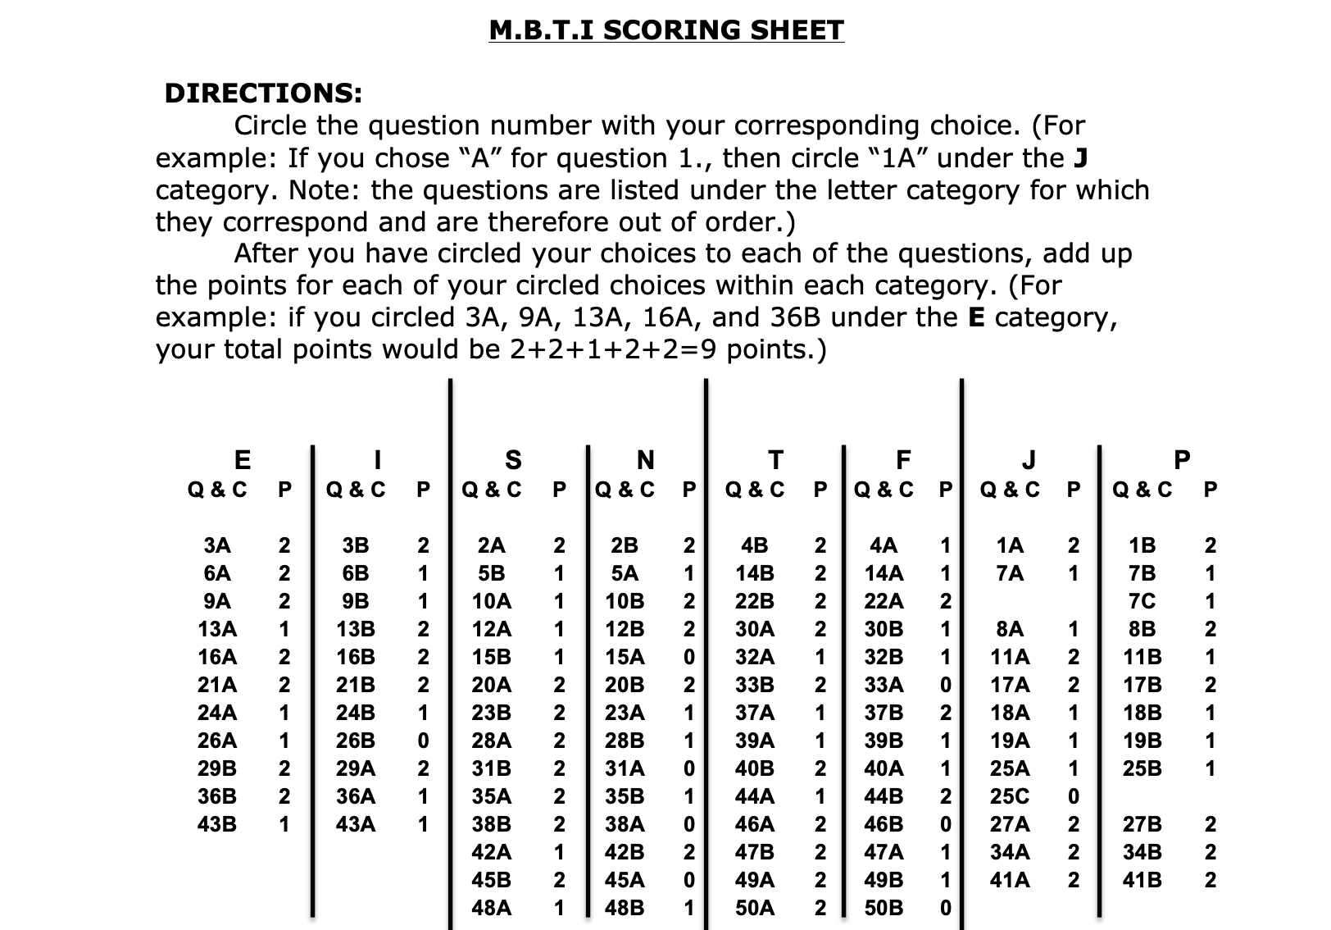

Scoring For Personality Trait

In the above tabular representation:

E corresponds to Extrovert T correspond to Thinking

I correspond to Introvert. F correspond to Feeling

S corresponds to Sensing J correspond to Judging

N corresponds to Intuitive P correspond to Perceiving

In case of a tie, between

1) between E & I, select I

2) between S & N, select N

3) between T & F, male will select ‘T’ & females ‘F’

4) between J & P, select P

Our dataset after having the personality trait would look like this:

|  |  |  |  |  |  |  |  |  |  |
| --- | --- | --- | --- | --- | --- | --- | --- | --- | --- |
| Name | Gender | Co- Curricular? | . |  | . | . | . | Personality Trait | Teaching Style |
| Priyanshu | Male | Yes |  |  |  |  |  | ESTJ |  |
| Yashwanth | Male | No |  |  |  |  |  | ENFP |  |
|  |  |  |  |  |  |  |  |  |  |
|  |  |  |  |  |  |  |  |  |  |

#### Creating a Database That Maps Personality Traits to Students Conduct

According to the personality obtained, each student can be mapped to different teaching ways as discussed earlier.

|  |  |  |
| --- | --- | --- |
| Personality Trait | Class Activity | Take-Home Activity |
| *Introvert* | Straight-Forward Teaching | Individual Assignments |
| *Extrovert* | Interactive Teaching | Group Assignments |
| *Intuitive* | Discuss capabilities of future | Futuristic |
| *Sensing* | Discuss optimising the present | Ongoing Application |
| *Thinking* | Practical Examples |  |
| *Feeling* | Hypothetical Analogies |  |
| *Judging* | Focussed on Topic In Hand | Close-Ended |
| *Perceiving* | Exploring Other Topics | Open-Ended |

Our dataset after mapping the teaching trait would look like this:

|  |  |  |  |  |  |  |  |  |  |
| --- | --- | --- | --- | --- | --- | --- | --- | --- | --- |
| Name | Gender | Co- Curricular? | … | … | Personality Trait | Group-Activity | Imaginative | … | … |
| Priyanshu | Male | Yes |  |  | ESTJ | No | Yes |  |  |
| Yashwanth | Male | No |  |  | ENFP | No | Yes |  |  |
|  |  |  |  |  |  |  |  |  |  |
|  |  |  |  |  |  |  |  |  |  |

#### Using Machine Learning Techniques and Algorithms

A flow chart for our model looks like:

We intend to apply various ML techniques and then choose the algorithm that gives us the best accuracy.

1. K-Means : The combination of personality traits under the 4 heads would yield 16 possible combinations of personalities. We would try clustering with different values of k (ranging from k =2 to k=16) and then according to the elbow plot, we would consider the appropriate number of clusters.

After clustering we would investigate each cluster. The cluster would be dedicated to that teaching style which would be in majority in any cluster. The rest of the data points will be treated as misclassified samples.

Based on the cluster density of various clusters, we would be able to judge the apt teaching method suited to most of the class.

The ground truth would then be used to cross-check if the clustering was in the correct lines or not.

1. Random Forest: This would include splitting the dataset into test and train part. With the train part and the ground truth we would train our model.

With the rest of the data, we would test our model.

The misclassification error would be used to judge the accuracy of the model.

After having a well-trained model, we would use it to predict the preferred teaching style of student for whom ground truth is not known.

According to majority methodology we would determine the preferred teaching style of the students.

1. SVC: Similar methodology as discussed for random forest would be used to get the accuracy of SVC.

#### Final Analysis and Testing our Model.

The final analysis of the model can be done when a student completes a course via feedback forms. In the feedback form a dedicated section of 4 questions regarding the teaching methodology can be asked from the students.

*For example*: *According to our analysis and model ‘Extroverted-Intuitive-Thinking-Judging’ are found to be dominant personality traits. Accordingly, we design our curriculum with teaching that maps to the obtained personality traits. In the feedback we would include questions which would ask the students if they wished for the converse of what method was adopted or enjoyed the methodology adopted.*